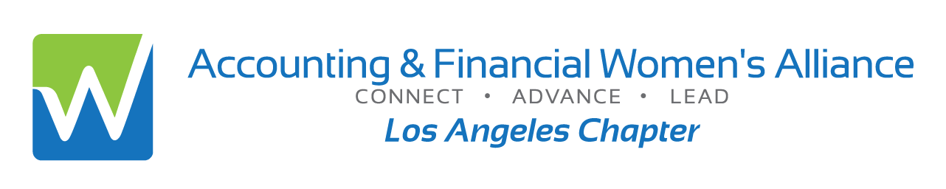

**Professional Ethics Updates**

**and the Role of Trust, Ideology, and Complicity**

**Dr. Lawrence Kalbers, Ph.D., CPA**

R. Chad Dreier Chair in Accounting Ethics

Loyola Marymount University



This presentation reviews ethical foundations and professional responsibilities. It includes a discussion of the role of trust, ideology, and complicity in understanding ethical and unethical behavior.

* Recognize, understand, apply, and analyze real-life situations using an ethical decision model.
* Understand, apply, and analyze the importance of the lack of trust, ideology, and complicity in unethical behavior.
* Understand the impact of professional ethics and values on clients, financial markets, and society.
* Overview, no prerequisite, virtual
* Qualifies for 2 hours Ethics CPE

|  |  |
| --- | --- |
| Date: | Wednesday, December 11, 2024 |
| Time: | 5:00 pm: Logging on & Networking  5:30-7:30 pm: Program |
| Location: | Zoom Virtual Session- invitation links upon responding |
| Cost: | $20: Members or Students$25: Non-members or Guests *please RSVP by Dec 9th; No Refunds; + $5 after Dec 9th  Late Sales end Dec 11th at 3 pm  To reserve on line with a credit card to:  <https://afwa-ima-ethics2024.eventbrite.com> |
|  |  |
| Information: | *Annette Christensen,* [*MsAinLA@yahoo.com*](mailto:MsAinLA@yahoo.com)*,* 213-359-9835 |

**Speaker Information**

**DR. LAWRENCE KALBERS**

Dr. Lawrence (Larry) Kalbers is a Professor of Accounting and the R. Chad Dreier Chair in Accounting Ethics. He earned a B.A. from Wittenberg University, an M.S. from Kent State University, and a Ph.D. from Penn State University. His teaching interests include accounting and business ethics, auditing, and financial reporting. His research interests include audit committees and corporate governance, professionalism, auditor burnout, auditor organizational commitment, destructive leadership behavior, and professional ethics.

Dr. Kalbers is a CPA and a member of the American Institute of CPAs, the American Accounting Association, the Institute of Internal Auditors, the National Association of Black Accountants, and the California Society of CPAs.

# Official National Registry Statement

The Accounting & Financial Women’s Alliance (formerly American Society of Women Accountants) is registered with the National Association of State Boards of Accountancy (NASBA) as a sponsor of continuing professional education on the National Registry of CPE Sponsors. State boards of accountancy have final authority on the acceptance of individual courses for CPE credit. Complaints regarding registered sponsors may be submitted to the National Registry of CPE Sponsors through its website: https://nasba.org.