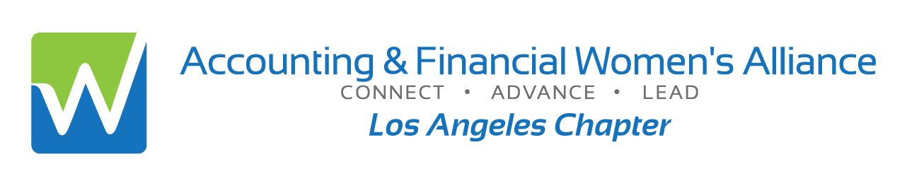

JOINT MEETING WITH IMA METRO

Beyond the Numbers: Risk Management
for Visionary Leaders in Finance
Christine Battist
Board Director for Capital Southwest Corporation,
Bolt Project Holdings, Inc., and Highland Bank

In today’s dynamic environment—shaped by rapid technological innovation, geopolitical uncertainty, economic fluctuations, and shifting regulatory demands—financial leaders face a landscape of complexity and constant change. To thrive amid these challenges, it’s essential to cultivate a proactive risk management mindset. In this presentation you will:

- Learn how to strategize thinking into decision-making

- Learn how to foster organizational resilience

- Learn what drives sustainable growth in an increasingly unpredictable world.

- Overview, no prerequisite, virtual
- Qualifies for 1 hours CPE
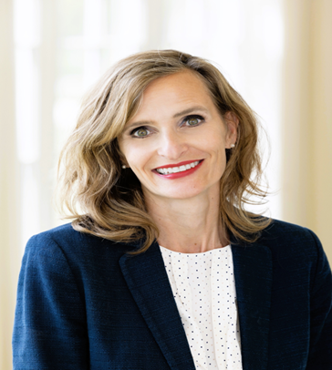
Date: | Thursday, November 20, 2025
Time: | 5:30 pm: Logging on & Networking  6:00-7:00 pm: Program
Location: | Zoom Virtual Session- invitation links upon registering
Cost: | $10: Members or Students; $15: Non-members or Guests  *please RSVP by Nov 18th; No Refunds; + $5 after Nov18th  Late Sales end Nov 20th at 3 pm  To reserve on line with a credit card to:  https://afwa-ima-riskmgt.eventbrite.com
Information: | Annette Christensen, MsAinLA@yahoo.com, 213-359-9835
Speaker Information

CHRISTINE BATTIST
Bio: Christine Battist is an independent board member and accomplished global financial executive, recognized for driving transformational growth and leading complex capital market transactions across public and private companies. She has led numerous strategic M&A initiatives, successfully managed acquisition integrations, and structured sophisticated financing solutions. Her leadership spans companies from start-up through IPO, as well as PE-backed and Fortune 500 organizations, with deep expertise in financial services, real estate, and chemicals. Christine currently serves as a Board Director for Capital Southwest Corporation (NASDAQ: CSWC), Bolt Project Holdings, Inc. (NASDAQ: BSLK), and Highland Bank. Dedicated to community engagement, she also serves on the Board of Directors for Girl Scouts River Valleys.

Official National Registry Statement
The Accounting & Financial Women’s Alliance (formerly American Society of Women Accountants) is registered with the National Association of State Boards of Accountancy (NASBA) as a sponsor of continuing professional education on the National Registry of CPE Sponsors. State boards of accountancy have final authority on the acceptance of individual courses for CPE credit. Complaints regarding registered sponsors may be submitted to the National Registry of CPE Sponsors through its website: www.NASBARegistry.org.

