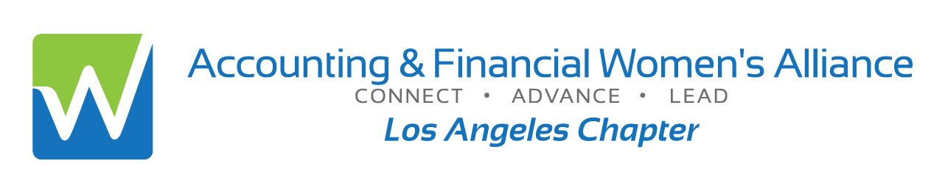
ANNUAL TAX UPDATE FOR 2026
Guest Speaker: Kip Dellinger, CPA
Joint meeting with the Institute of Management Accountants
- Learn About Highlights of the One Big Beautiful Bill Act (OBBBA)
- Learn Tax Developments for 2025
- Overview, update, no prerequisites, virtual
- CPE Credit: 2 hours

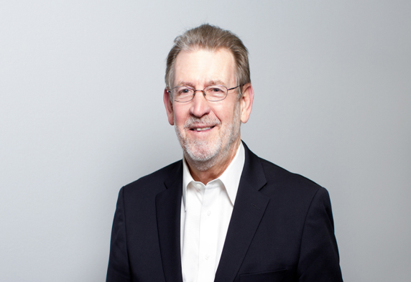

Date: | Wednesday, January 21, 2026
Time: | 5:30 p.m. - Login & Networking  6:00-8:00 p.m. - Program
Location: | Zoom Virtual Session- invitation links upon responding
Cost: | $20: Members or Students  $25: Non-members or Guests  *please RSVP by Jan 18th; No Refunds; + $5 after Jan 18th  Late Sales end Jan 21st at 3 pm  To reserve online by credit card go to:  https://afwa-ima-tax2026.eventbrite.com
Information: | Annette Christensen, 213-359-9835, MsAinLA@yahoo.com
Speaker Information:
Kip Dellinger, Senior Tax Partner of Kallman & Company, LLP has extensive experience involving sophisticated income tax planning and handling of tax controversy matters for high-income individuals, family owned and closely held businesses, fiduciaries, and estates. His industry experience includes manufacturing, entertainment industry, and real estate developers, operators and investors. Kip is the author of the volume Federal Tax Practice Standards for the CCH Tax Practice & Procedure Library. Kip is a member of the AICPA Tax Division Tax Practice Responsibilities Committee and the Division’s Task Force on Quality Control Standards for Tax Practice. He was also a member of the Tax Division’s Circular 230 Working Group.

Official National Registry Statement
The American Society of Women Accountants (dba Accounting & Financial Women’s Alliance) is registered with the National Association of State Boards of Accountancy (NASBA) as a sponsor of continuing professional education on the National Registry of CPE Sponsors. State boards of accountancy have final authority on the acceptance of individual courses for CPE credit. Complaints regarding registered sponsors may be submitted to the National Registry of CPE Sponsors through its website: https://nasba.org.

